Laboratoriya ishi №4

Mavzu: Jadval yaratish va uni formatlash

Fan: Web ilovalar (HTML, CSS asoslari)

1. Ishdan maqsad
Veb sahifada HTML yordamida jadval (table) yaratish, unga sarlavha, ustunlar va satrlar qo‘shish, shuningdek CSS yordamida jadvalni bezatish va formatlashni o‘rganish.

2. Nazariy ma’lumot
HTMLda jadval yaratish uchun quyidagi teglar ishlatiladi:

Teg | Tavsif
<table> | Jadvalni belgilaydi
<tr> | Jadvaldagi satrni belgilaydi
<th> | Jadval sarlavhasidagi ustun (qalin matnli)
<td> | Jadvaldagi hujayra (ma’lumot qatori)
<caption> | Jadval sarlavhasi (nomi)
<thead>, <tbody>, <tfoot> | Jadval qismlarini ajratadi

CSS yordamida jadvalni formatlash uchun esa quyidagi xususiyatlardan foydalaniladi:
border – jadval va hujayra chegarasi
border-collapse – chegaralarni birlashtirish
padding – hujayra ichidagi masofa
text-align – matn joylashuvi
background-color, color – ranglar bilan bezatish

3. Amaliy qism (Kod namunasining to‘liq varianti)

HTML fayl (index.html):
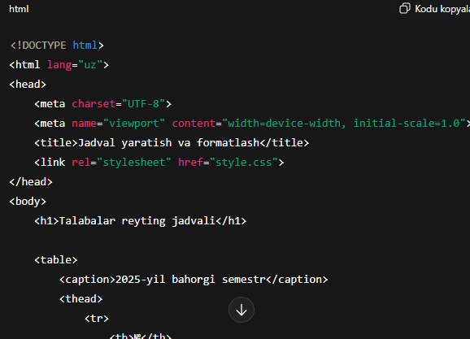
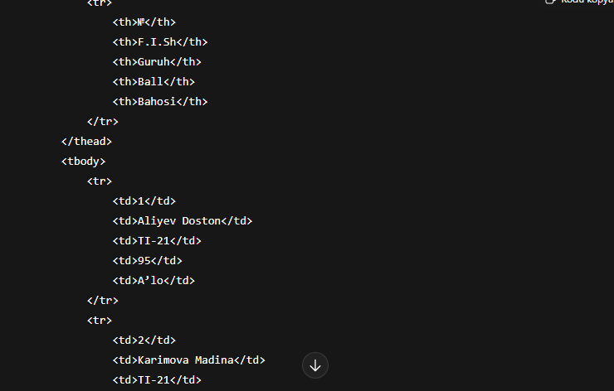

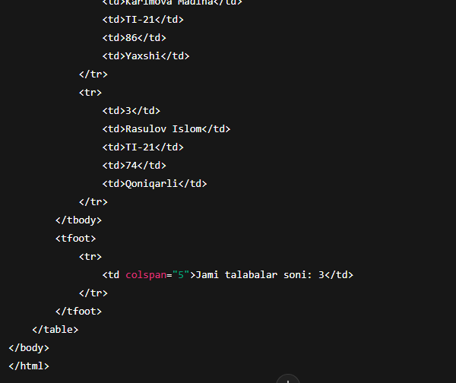

CSS fayl (style.css):
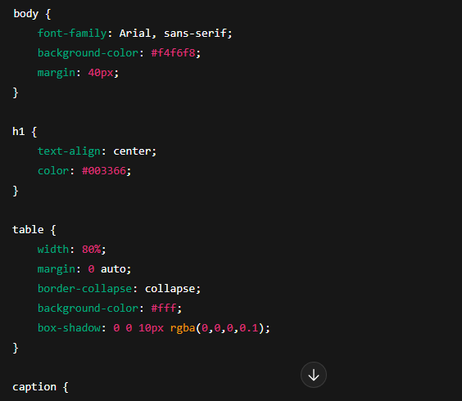

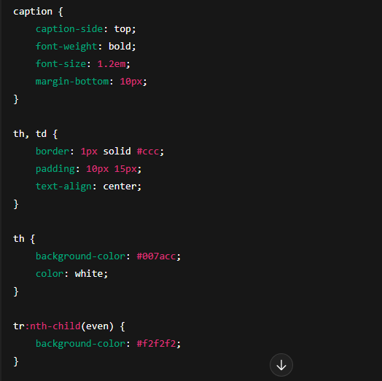
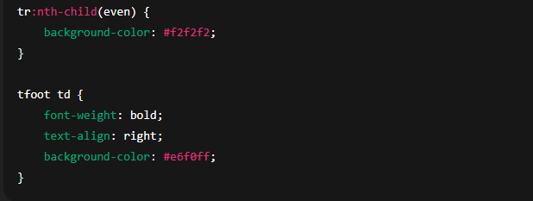

4. Natija
Ushbu kod natijasida quyidagi ko‘rinishga ega veb-sahifa hosil bo‘ladi:
Jadval markazda joylashgan
Sarlavha qismi rangli va markazlashgan
Qatorlar navbat bilan oq va kulrang fonli
Jadvalga soyali dizayn berilgan
Topshiriq: Sumka do’konining sayti

<!DOCTYPE html>
<html lang="uz">
<head>
<meta charset="UTF-8">
<title>Brend Sumkalar Do'koni</title>
<style>
body {
font-family: Arial, sans-serif;
background-color: #ffc0cb; /* Pushti fon */
margin: 20px;
}
h1 {
text-align: center;
color: #fff;
text-shadow: 1px 1px 2px #000;
}
.container {
display: flex;
flex-wrap: wrap;
justify-content: center;
gap: 20px;
}
.product {
background-color: #fff;
border: 1px solid #ddd;
border-radius: 8px;
width: 250px;
padding: 10px;
box-shadow: 0 2px 5px rgba(0,0,0,0.1);
}
.product img {
width: 100%;
height: auto;
border-radius: 5px;
}
.product h2 {
font-size: 18px;
margin: 10px 0 5px;
text-align: center;
}
.product p {
font-size: 16px;
color: #555;
text-align: center;
}
</style>
</head>
<body>
<h1>Brend Sumkalar Do'koni</h1>
<div class="container">

<div class="product">
<img src="https://lombard-chasov.ru/images/products/WGhLHVZZblM0aJVNIeBFB6Wf2x3Ol0awkmsytSf4.jpg" alt="Chanel sumkasi">
<h2>Chanel</h2>
<p>Narxi: 250 000 so'm</p>
<p> Qizil, Oq, Qora ranglari bor</p>
</div>
<div class="product">
<img src="https://images.satu.kz/182561790_w640_h640_sumka-gucci-gg.jpg" alt="Gucci sumkasi">
<h2>Gucci</h2>
<p>Narxi: 300 000 so'm</p>
<p> To'q qizil, Oq, Qora ranglari bor</p>
</div>
<div class="product">
<img src="https://images.prom.ua/6582789822_w640_h640_sumka-louis-vuitton.jpg" alt="Louis Vuitton sumkasi">
<h2>Louis Vuitton</h2>
<p>Narxi: 200 000 so'm</p>
<p> Oq, Kulranglari bor</p>
</div>
<div class="product">
<img src="https://cdn1.ozone.ru/s3/multimedia-1-5/c600/7056374333.jpg" alt="Dior sumkasi">
<h2>Dior</h2>
<p>Narxi: 280 000 so'm</p>
<p> Oq va Pushti gulli ranglari bor</p>
</div>
<div class="product">
<img src="https://images.prom.ua/6522454428_w640_h640_zhenskaya-sumka-stil.jpg" alt="Zara sumkasi">
<h2>Zara</h2>
<p>Narxi: 450 000 so'm</p>
<p> Oq, Qora Kulranglari bor</p>
</div>
<div class="product">
<img src="https://images.uzum.uz/cmu93m125kub33f23do0/original.jpg" alt="Hermès sumkasi">
<h2>Hermès</h2>
<p>Narxi: 350 000 so'm</p>
<p> Har xil turdagi ranglari bor</p>
</div>
</div>
</body>
</html>

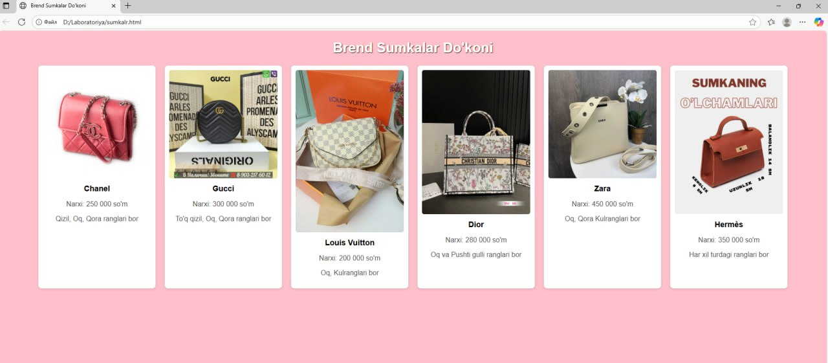

5. Xulosa
Mazkur laboratoriya ishida HTML va CSS yordamida jadval yaratish, unga ustun va satrlar qo‘shish, hamda CSS orqali formatlash o‘rganildi. Bu usul yordamida ma’lumotlarni tartibli va ko‘rkam shaklda veb-sahifada ifodalash mumkin.

